Assignment -3

BUILD CNN MODEL FOR CLASSIFICATION OF FLOWERS

|  |  |
| --- | --- |
| Assignment Date | 05.11.2022 |
| Student Name | G.SAMSON |
| Student Roll Number | 814619106301 |
| Maximum Marks |  |

***BUILD CNN MODEL FOR CLASSIFICATION OF FLOWERS***

## *FLOWCHART*



Data collection

Automatic

feature extraction

Train dataset

Build CNN model

Dataset creation

## 



Model evaluation

**I**

Test dataset

**Number of images according to the types of flowers.**

|  |  |  |
| --- | --- | --- |
| **S. No** | **Types of Flowers** | **No of images** |
| 1. | Daisy | 633 |
| 2. | Dandelion | 898 |
| 3. | Rose | 641 |
| 4. | Tulip | 699 |
| 5. | Sunflower | 799 |
| Total number of Images | | 3670 |

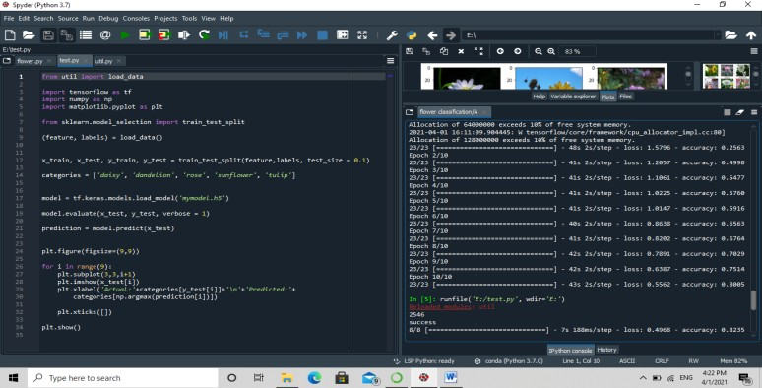

## Loading Dataset

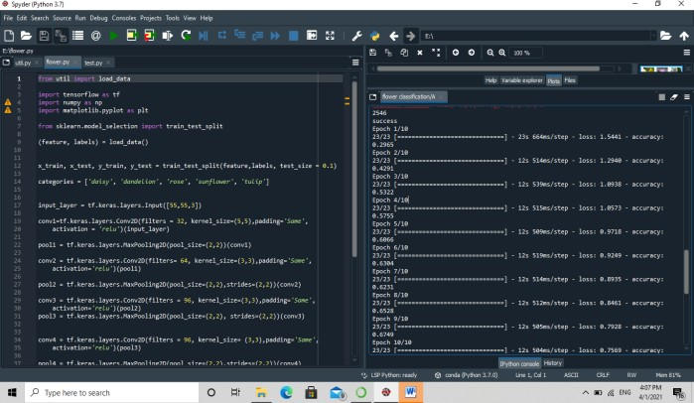

**Testing Data**

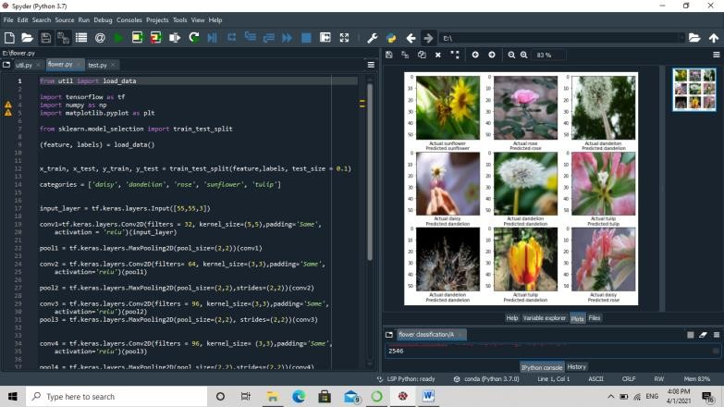

## 

## Image Classification

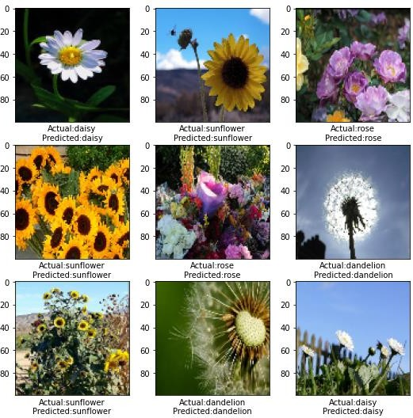

**Classification and Prediction of the Flowers**